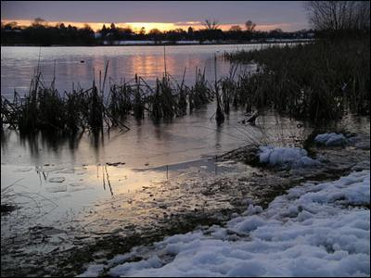

February Snow

Water
Of
Life

27 February 2022

W A T E R O F L I F E

Independent Christian Church—Conservative Lutheran Doctrine

Worship Service: 9:30 a.m. Bible Study: 10:45 a.m.

Larry Cooper, Pastor E-Mail address:
111 N. Ridge Road lcooper@wateroflife.cc
Coon Valley, WI 54623 Web Site:
www.wateroflife.cc

* * * * * * * * * * * * * * * * * * * * * * * * * * *

Sermon Text: Luke 12:8-12

The Great Teacher

* * * * * * * * * * * * * * * * * * * * * * * * * * *
8 Also I say unto you, Whosoever shall confess me before men, him shall the Son of man also confess before the angels of God:
9 But he that denieth me before men shall be denied before the angels of God.
10 And whosoever shall speak a word against the Son of man, it shall be forgiven him: but unto him that blasphemeth against the Holy Ghost it shall not be forgiven.
11 And when they bring you unto the synagogues, and unto magistrates, and powers, take ye no thought how or what thing ye shall answer, or what ye shall say:
12 For the Holy Ghost shall teach you in the same hour what ye ought to say.



Order Of Service

Opening Hymn: TLH 140

Reading: Lent I

The History of the Passion of our Lord

Sermon Hymn: TLH 142

Sermon Text: Luke 12:8-12

The Great Teacher

Confession of Sins: O almighty God, merciful Father, I, a poor miserable sinner, confess unto Thee all my sins and iniquities, with which I have ever offended Thee and justly deserved Thy temporal and eternal punishment. But I am heartily sorry for them and sincerely repent of them, and I pray Thee of Thy boundless mercy and for the sake of the holy, innocent, bitter sufferings and death of Thy beloved Son, Jesus Christ, to be gracious and merciful to me, a poor, sinful being.

Holy Communion

The Lord's Prayer

The Blessing

Closing Hymn: TLH 147

* * * * * * * * * * * * *

Bible Study: Lambs: Red Start
Sheep: Philippians

